Project Design Phase-II
Data Flow Diagram & User Stories

Date | 08 July 2026
Team ID
Project Name | Sports Hall Booking System
Maximum Marks | 4 Marks

Data Flow Diagrams:

A Data Flow Diagram (DFD) is a traditional visual representation of the information flows within sports hall booking system. A neat and clear DFD can depict the right amount of the system requirement graphically. It shows how data enters and leaves the system, what changes the information, and where data is stored.

The Data Flow Diagram (DFD) illustrates how information moves through the Sports Hall Booking System. It shows how the user interacts with the system, how booking information is processed, and how data is stored in the database.

Example:

The Data Flow Diagram demonstrates that the Sports Hall Booking System efficiently manages sports hall reservations by allowing users to book available slots online, validating bookings to avoid conflicts, storing booking information securely in the database, and enabling administrators to manage all reservations through the ServiceNow platform.
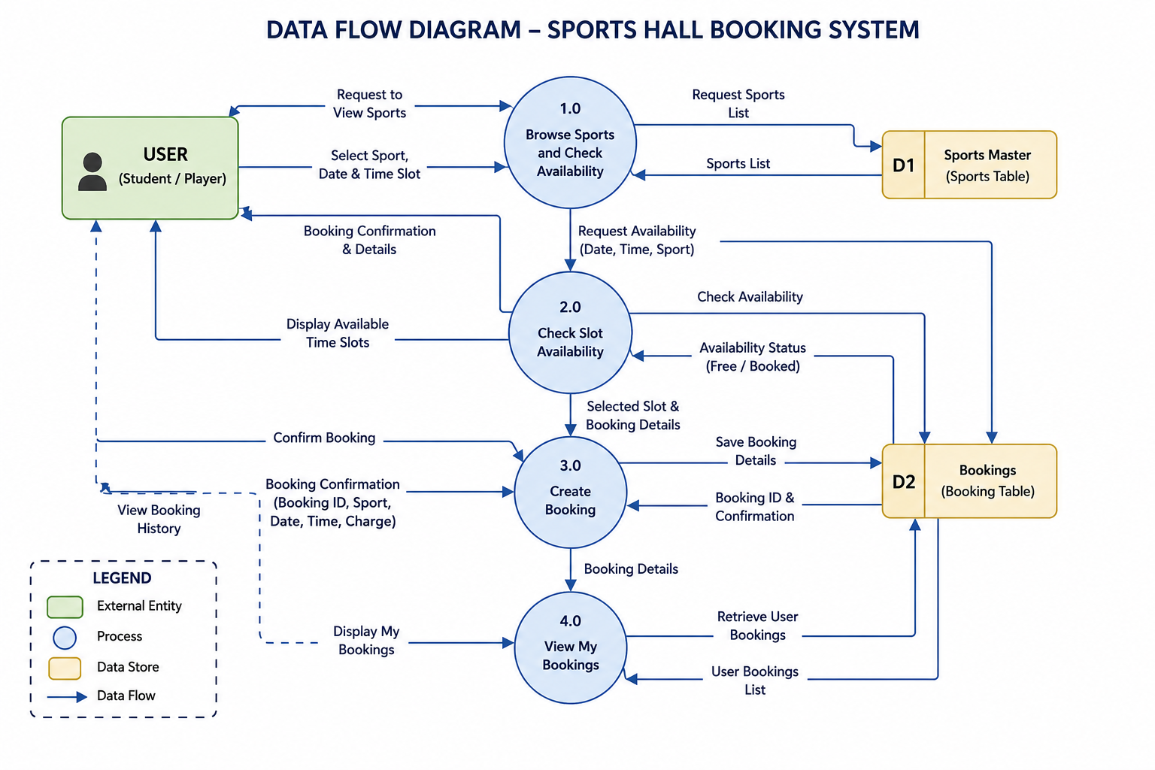

User Stories

User type | Functional requirements | Story | priority
Student | Select Sport | As a student, I want to select my preferred sport so that I can book the appropriate sports hall. | High
Student | View Available Time Slots | As a student, I want to view only available one-hour time slots so that I can avoid booking conflicts. | High
Student | Book Sports Hall | As a student, I want to reserve an available sports hall online so that I can use the facility at my preferred time. | High
Student | View Booking Details | As a student, I want to view my booking information so that I can track my reservations. | Medium
Administrator | Manage Bookings | As an administrator, I want to view and manage all sports hall bookings so that I can monitor facility usage efficiently. | High
Administrator | Prevent Duplicate Bookings | As an administrator, I want the system to automatically prevent duplicate bookings so that scheduling conflicts are avoided. | High

